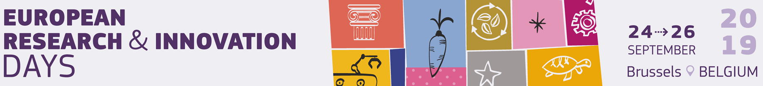
Session: Bio-based innovations in practice
26/09/2019, 10 – 11 am, Room 10 “Pasteur”
The session will look at bio-based innovation: main challenges and potentials (research, macro-regional (Bio-EAST), industrial and environmental aspects), and future R&I (Intervention Area 6.4 “Bio-based innovation Systems”, and potential European Partnership for a Circular bio-based Europe).
FINAL AGENDA

10.00-10.05 | Welcome | Ignacio Martin, CIRCE Foundation  Introduction of topic and speakers
10.05-10.21 | Q1: “What are the main challenges and potentials?”  TED-like talks  [4’ each] | Malene Sand Jespersen, COVI A/S  Research perspective: Bio-based products - key enablers and barriers to innovation and commercialisation  Barna Kovács, BIOEAST Initiative  Macro-regional perspective  Riccardo Schiatti, Energochemica  Industrial perspective  Holger Gerdes, Ecologic Institute  Environmental / regional perspective
10.21-10.31 | Q & A
10.31-10.45 | Q2: “What should be the focus of the future R&I?”  Panel discussion | Malene Sand Jespersen  Barna Kovács  Riccardo Schiatti  Holger Gerdes
10.45-10.55 | Q & A
10.55-11:00 | Closing remarks | Ignacio Martin  Summarising take-away messages

Please see the short bios of the moderator and panellists on the other side
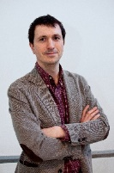
Moderator
Ignacio Martin, Head of Strategic Partnering, CIRCE Foundation, Zaragoza, ES; coordinator of the Horizon 2020 Power4Bio project (“emPOWERing regional stakeholders for realising the full potential of european BIOeconomy”). Chemist, starting at the University of Autonoma of Madrid (Spain), where he graduated with the Degree of Inorganic Chemistry in 2000. Since then, he has accounted over 17 years of experience in project management and developing, monitoring and reporting R+D projects in the field of chemistry and environment, as well as bioeconomy strategies development.
Panellists

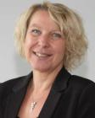
Malene Sand Jespersen, Market Director, COVI A/S, DK; Contributing author to the 2018 Study "BIO-SPRI - Bioeconomy: Support to Policy for Research and Innovation”, chapter ‘Bio-based products From idea to market - 15 EU success stories’. Economist with more than 25 years of experience in managing the delivery of consultancy services to the European Commission in areas such as climate action, EU funding, green finance, environment, renewable energy and bio-economy.
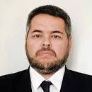
Barna Kovács, BIOEAST Initiative Secretary General, Permanent Representation of Hungary to the EU, HU. The counsellor at the Permanent Representation of Hungary to the EU, Secretary General of the BIOEAST Initiative. Between 2009-2017 scientific and policy officer in the European Commission, covered research project management and policy definition, contributing to conceptual reflections of the work programmes, strategic documents and new approaches for the implementation of the EU Bioeconomy Strategy, the Bioeconomy Observatory and Standing Committee on Agricultural Research.

Riccardo Schiatti, Energochemica, Director of BBI JU BIOSKOH Flagship project “Innovation Stepping Stones for a novel European Second Generation BioEconomy”. Director-Executive Vice President, expert in developing and implementing high-level strategies to facilitate business growth and increase profitability. Focused on Agro-Industrial and Bio-chemical initiatives for over 12 years. CEO at Biochemtex Agro and Supply Chain Director at Biochemtex Group, set up and managed the supply chain for the first Industrial scale 2G Ethanol plant.

Holger Gerdes, Coordinator Bioeconomy, Senior Fellow Ecologic Institute, Berlin, DE; coordinator of the BE-Rural project (“Bio-based Strategies and Roadmaps for Enhanced Rural and Regional Development in the EU”). Senior Fellow at Ecologic Institute and coordinator of the Institute's bioeconomy activities. He evaluates and applies participatory tools for the effective management of natural resources in the emerging bioeconomy. Having a background in environmental and resource economics, he also works on the economic valuation of biodiversity and ecosystem services and on the assessment of the socio-economic implications of environmental change.

https://power4bio.eu/ ; https://cordis.europa.eu/project/rcn/218337/factsheet/en
https://publications.europa.eu/en/publication-detail/-/publication/23ab58e0-3011-11e9-8d04-01aa75ed71a1
http://bioeast.eu/
https://cordis.europa.eu/project/rcn/204326/factsheet/en ; https://bbi-europa.eu/projects/bioskoh
www.be-rural.eu; https://www.ecologic.eu/16408 ; https://cordis.europa.eu/project/rcn/222537/factsheet/en

