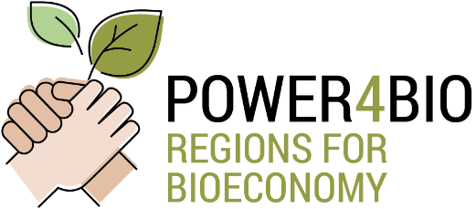
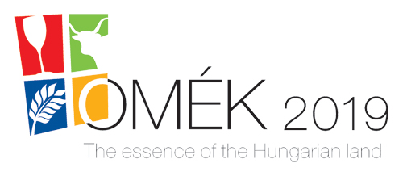
CROSS-VISIT IN HUNGARY

From September 2019 to the end of the project, regular meetings will be organized for all the project partners, regional stakeholders, policy-makers and Community of Interest (CoI) members. These meetings i.e. ’cross-visits’ will offer great opportunities to get a view of the activities of the 10 regions in the POWER4BIO Project. The participants will receive information on business models, best practices, existing and potential value-chains, and cross-border collaboration possibilities in the bioeconomy.
The 1st cross-visit will take place in Budapest and Kecskemét, Hungary from 25 to 26 September in collaboration with the National Agriculture and Food Exhibition and Fair of Hungary (OMEK). The Southern Great Plain Region Partner - Bay Zoltán Nonprofit Ltd. for Applied Research (BZN) - will be the host of the event in close cooperation with NARIC - Research Institute of Agricultural Economics.
The detailed programme of the cross-visit is forthcoming, but we can already share some information:
The programme will start at 9 A.M. on the 25th September 2019 in Budapest (Hotel Aquincum). The introduction and orientation will be followed by a group work involving an innovation game and future-thinking methodology, and then by the field visit to Pilze-Nagy Ltd. (Kecskemét), a leading company in the field of biomass utilization. Two ways of biomass utilization will be presented; namely mushroom production on straw and biogas production. The day will conclude with a feedback session including the results of the field visits and group activities.
The 2nd day – 26th September 2019 – of the programme will start with an alternative field visit at OMÉK (National Agriculture and Food Exhibition and Fair), which attracts the most important actors of the Hungarian agro-food sector. The local host (BZN) will contact the companies active in the bioeconomy field and pre-organise visits to their booths. Cross-visit participants will have the opportunity to visit of 3-5 of these companies and to get in closer contact with them between 9 A.M. and 2 P.M. In the afternoon (2 P.M. to 5.30 P.M.) a symposium will close the event with the proposed subject: vision and collaboration opportunities of bioeconomy-related organisations. Topics discussed will include the vision and strategy of the Hungarian Bioeconomy Cluster; Available regional funding for supporting bioeconomy; Bioeconomy in the EU and at regional level: SCAR – AKIS, BIOEAST; Climate Policy and Bioeconomy; Presentation of the Bioeconomy Group of the Hungarian Agricultural Chamber).

IMPORTANT NOTES:
Stakeholders not being members of the Power4Bio consortium are expected to bear their own travel cost to Budapest and the accommodation expenses in town. Participation in the cross-visit is free of charge, but pre-registration is required, along with registration to OMÉK, which opens soon at the OMÉK webpage.
Recommended accommodation in Budapest: Aquincum Hotel.
Venue of OMÉK: Hungexpo Budapest Fair Centre, Budapest

If you have any questions, please do not hesitate to contact us via email: power4bio@aki.naik.hu

Please visit our website frequently and follow us on LinkedIn; Facebook; Twitter

