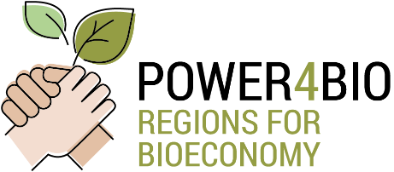

Cross-visit in Naples, Italy
From September 2019 to the end of the project, regular meetings will be organized for all the project partners, regional stakeholders, policy-makers and Community of Interest (CoI) members. These meetings i.e. ’cross-visits’ will offer great opportunities to get a view of the activities of the 10 regions in the POWER4BIO Project. The participants will receive information on business models, best practices, existing and potential value-chains, and cross-border collaboration possibilities in the bioeconomy.
The 2nd cross-visit will take place in Naples, Italy (Congress Center of University of Naples Federico II, via Partenope 36), from the 2nd to the 4th October, coinciding with the International Forum on Industrial Biotechnology and Bioeconomy. This cross-visit will be organised by SPRING and NARIC - Research Institute of Agricultural Economics.
The detailed programme of cross-visit is still in progress, but we can already share some information:
The afternoon of October 2nd (indicatively 14.00 – 18.00) will be organized with an initial session where regional stakeholders (policy makers, industry, research entities and associations) from Italian regions will present their activities and a second workshop-session where different aspects of bioeconomy will be discussed. (e.g. The new Italian Bioeconomy Strategy; The fifth report on Bioeconomy by Intesa Sanpaolo, with a specific focus on the wood/forestry value chain; A focus on bioplastics, by Assobioplastiche; An overview on R&D activities on bioeconomy in Italian regions; The SPRING roadmaps to support bioeconomy development in Italian regions)

The aim of the afternoon is to facilitate the exchange of information and inputs on best practices (from both a technical and a policy-making point of view), and bio-based solutions.
October 3rd and the morning of October 4th will consist of the IFIB event, which is co-organized by SPRING, where several aspects of bioeconomy (bio-based industries; the bio-based economy and the creation of value chains; energy and environment; education in the circular bioeconomy; agrofood; the role of cities and regions in the circular bioeconomy) will be discussed.
October 4th, in the afternoon: field visit to the Novamont’s R&D center at Piana di Monte Verna (near Naples, transportation organized by SPRING)
IMPORTANT NOTES:
Stakeholders not being members of the Power4Bio consortium are expected to bear their own travel cost to Naples and the accommodation expenses in town. Participation in the programme is free of charge, but pre-registration is required.

Registration to IFIB is also required for participation (is free of charge) at https://ifib-2019.b2match.io/signup (choose the conference of both October 3rd and 4th)

The FIELD VISIT IS OPEN TO A MAXIMUM OF 30 PEOPLE, so we kindly ask you to BOOK the visit (the visit is open to all stakeholders, but P4B partners will be given priority). You can directly send an e-mail to Sara Tidi (cantotidi@gmail.com) with comunicazione@clusterspring.it in cc.

Please visit our website frequently and follow us on LinkedIn; Facebook; Twitter

